**Introduction**

**Methods**

The experiment was performed at the matter of extreme conditions (MEC) endstation of the Linac Coherent Light Source (LCLS), where XFEL pulses were used to isochorically excite MgO samples consisting of 100 nm-thick layer of MgO nanoparticles deposited onto an 8 um-thick kapton substrate and confined using a binding matrix of Poly(methly methacrylate) (PMMA). We used pulses of duration of 30 fs (check this), with mean pulse energies of 2 mJ (check this) and an x-ray energy of 9 keV. The intensity of every shot was measured using an upstream nitrogen fluorescence detector (check this). We controlled flux density incident on the sample via a stack of Be lenses, with which we varied the focal spot diameter of XFEL pulses at the sample position from 2 to 58 um; these diameters were determined using an ablative imprint method to measure the spatial profile of the focused XFEL beam (cite <http://doi.org/10.1016/j.nima.2010.12.040>). Using the full available range of focal spot sizes and a constant (unattenuated) beam intensity, we obtained incident flux densities ranging from 30 J/cm^2 to ????.

During data collection the sample's position was rastered at a rate of 100 um (*check this*) between the XFEL pulses, whose repetition rate was 120 Hz. At every XFEL pulse the Bragg scattering signal was collected and read out from a quad CSPAD solid state detector having 800 x 800 resolution and a pixel pitch of 100 um. (cite CSPAD papers) The 8 x 8 cm^2 active area of the detector subtended the range of scattering angles from 25 (check this) to 60 (check this) degrees, encompassing the 111, 200, and 220 Bragg reflections of MgO (located at x, y, and z degrees, respectively).

Several steps of processing and event selection were performed prior to generating powder diffraction patterns. For each event the quad CSPAD readout was corrected by subtracting pixel pedestals (measured using previously-collected dark exposures) as well common-mode noise in each of the detector’s 16 individual tiles. (cite CSPAD paper). Due to the small number of photon hits in a single shot (a consequence of the small sample thickness) residual ADC noise dominated the Bragg scattering signal. To address this we identified clusters of spatially-concentrated signal resulting from x ray photon hits, rejecting the output of noise-dominated pixels. The peak-finding algorithm used to do this is a standard component of the analysis pipeline for CSPAD data in low-photon count rate experiments at the LCLS, such as macromolecular imaging and crystallography. (*citation needed*).

For each LCLS pulse a powder diffraction pattern is generated from the quad CSPAD frame by the summation of elliptically-shaped strips of pixels at equal scattering angle. The mapping of pixel coordinate to scattering angle is calculated from the CSPAD’s location and orientation relative to the sample and incident XFEL beam; this geometry is in turn obtained from the conic section parameters of powder diffraction peaks in data from a known reference material measured in the same source-detector geometry. After generation of a powder pattern, two corrections are made. First, the each peak is shifted to correct for angular offsets caused by (2) the sample substrate’s lack of flatness and (2) event-to-event jitter in the energy of the XFEL pulse (as characterized by the downstream Si spectrometer). Second, a linear fit is made to the background of each peak, and this background is subtracted from the peak signal. The signal-to-background ratio for this peak is then computed by comparison of the background level derived from the linear fit to a simple integration of the background-subtracted peak. Events in which any of the peak signal-to-background ratios fall below a threshold (chosen to be 0.2) are rejected in subsequent summation over data from multiple events.

Bragg peak scattering intensity is the most significant derived quantity from each powder pattern in this study, but its estimation requires correcting the effect of variations in the total scattering signal caused by sample non-uniformity and temporal variation of the XFEL pulse energy. The latter contribution can be corrected using direct measurement of incident pulse intensities available from an upstream nitrogen detector; for comparison of Bragg peak intensities at different flux density values, however, we normalize each pattern to the integral intensity of its 200 peak in order to control for variations in sample thickness.

We note, finally, a complication involving measurement of this experiment's independent variable, the density of deposited energy. Due to the small sample thickness of 100 nm, a significant portion of high-energy Auger electrons and photoelectrons created in the sample necessarily escaped to the surrounding low-Z substrate and confining polymer, causing a reduction in the density of *deposited,* versus absorbed, energy. *(cite HEF paper and others)* This effect is illustrated in Fig *n*, and was quantified and accounted for using an electron transport simulation with the Monte Carlo code PENELOPE. (*More detail needed?)*

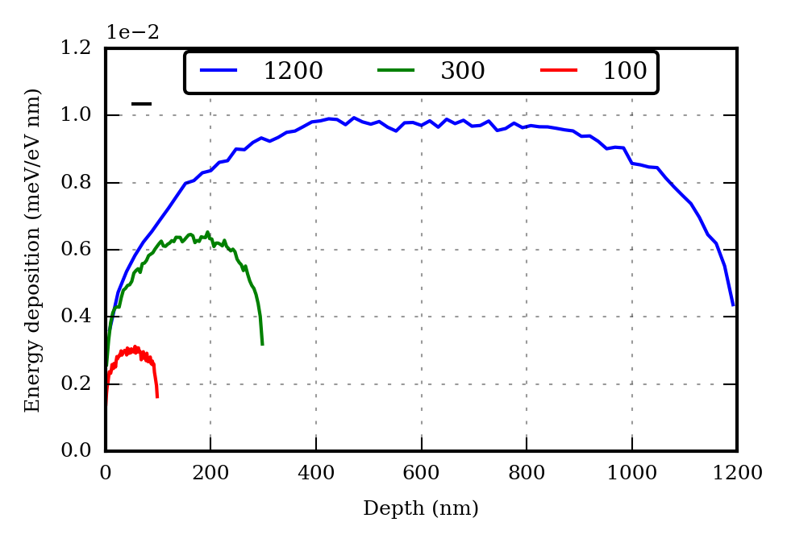

*(better figure needed here)*

**Results and discussion:**

In Fig. 1 we plot the intensity of the three lowest-order Bragg peaks of MgO as a function of incident flux density. For each Bragg peak, the entire curve is normalized to the intensity of the “cold” (lowest-flux density) dataset and each individual data point is normalized to the 200 peak intensity for the corresponding flux density. Displayed error bars are estimated systematic errors due to background subtraction and peak integration; counting statistics-derived errors are negligible. The most salient feature is a 20% rise in the relative intensity of the 111 peak between the lowest and highest flux densities. In contrast, the relative intensity of the 220 peak has small fluctuations but does not display a monotonic progression. Comparison to (*different figure, or panel in the same figure? Need something showing Debye-waller predictions*) demonstrates an absence of Debye-Waller lattice melting, which would entail a monotonic decrease in the intensity of higher-order Bragg peaks relative to lower-order ones (*Write expression for Debye-Waller quenching here?).* The experimental variation in relative Bragg peak intensities must therefore be explained in terms of electronic charge density reorganization caused by the thermalization of electronic degrees of freedom.

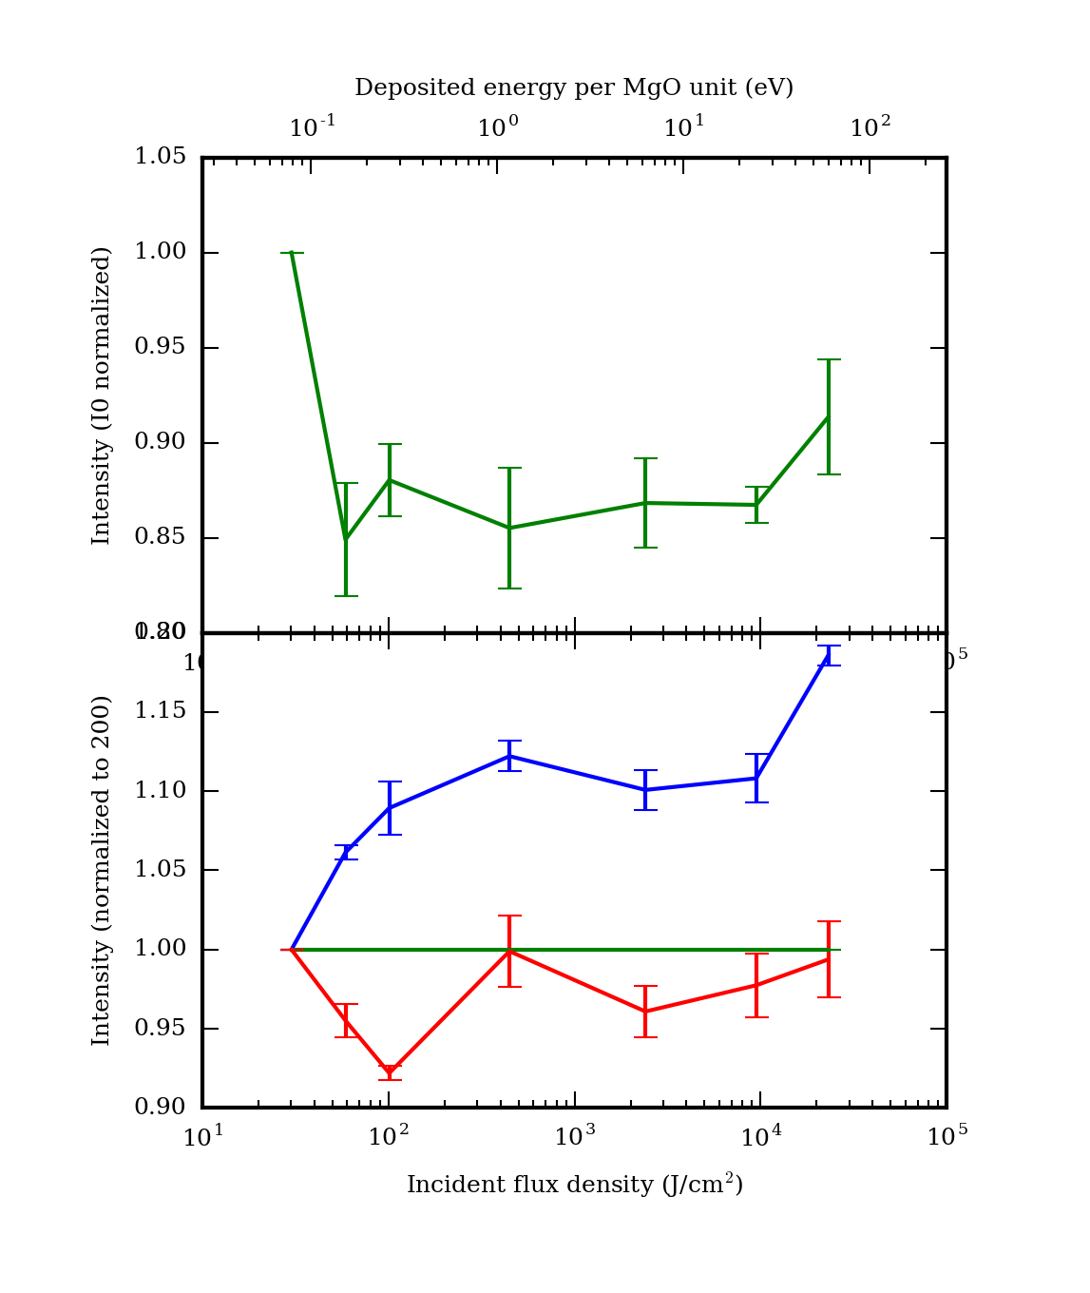

The increase in relative intensity of the 111 Bragg peak is understood by examining the structure of MgO in the context of the powder diffraction from a sample under ambient conditions (*figure reference? We don't really have a nice powder pattern to show*). MgO’s rock salt-type crystal structure consists of two interpenetrating FCC lattices of Mg and O, with one of the lattices shifted by half of the FCC lattice constant in the direction of (any) one of the lattice basis vectors. The two ionic species of MgO, Mg2+ and O2-, have identical electron configurations and therefore similar ionic form factors. If the ionic form factors were fully identical, the superposition of FCC lattices would become a simple cubic lattice with lattice constant a/2 (where a is the constant of the original FCC lattice), and under which Bragg reflections of the original FCC lattice having odd Miller indices are forbidden. In MgO, on the other hand, the modest difference between the atomic form factors of Mg2+ and O2- causes substantial—but incomplete—destructive interference at the momentum transfers of odd Miller indices. This offers an explanation for the small intensity of the 111 Bragg peak (*Fig. reference)*, as well as for its monotonic rise with increasing incident x-ray flux: as temperature increases the weakly-bound O 2p electrons are ionized, making the form factors of the O and Mg ions more dissimilar. Fig n (*make the figure)* illustrates the evolution of electronic charge density in 111 plane that accompanies this delocalization of the O 2p electrons.

To progress beyond a qualitative interpretation we now consider two models of electronic reorganization under heating that, while simplified, offer additional insight. In both models the atomic form factors of the Mg and O ions are calculated as a superposition of atomic subshell form factors obtained from the Hartree-Fock code of Cowan (cite). The crystal's structure factor is calculated as a sum over basis atoms; i.e.,

$S\left(\vec{Q}\right)=\sum_{j}{f{}_{j}\left(Q\right)e^{-i \vec{Q}∙\vec{r_{j}}} },$ (1)

Where $f{}_{j}\left(Q\right)$ is the atomic form factor of the jth species. The intensity of a given Bragg reflection (neglecting Debye-Waller quenching and the geometric dependence of scattering by a powder of crystallites) is then obtained by evaluating $S\left(h a_{1}+ k a_{2}+ l a_{3}\right)$, where $a_{1}, a_{2}$ and $a_{3}$ are the basis vectors of the reciprocal lattice and $h$, $k$ and $l$ are Miller indices. Following standard practice in plasma physics modeling, we treat ionization of atomic electrons as uniform (real-space) smearing of free electrons; thus, an atomic orbital is ionized by fractionally scaling its term in the form factor summation of (1*)*. *(cites. Can also use this as an opportunity to acknowledge probable inadequacy of this approach; finite-T DFT predictions of non-spherically symmetric charge reorganization*). We consider only ionization of the Mg 2p and O 2p orbitals, a simplifying approximation that's justified by the experiment's modest per-atom energy deposition, compared to the K-shell binding energies of Mg and O. (*Need to address why we ignore 2s as well. Doing so is valid in both models, but for different reasons).*

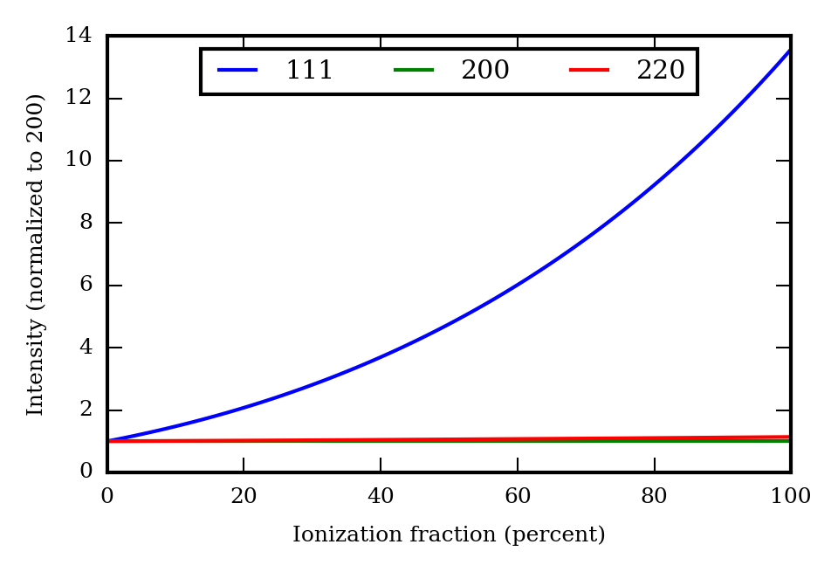

The first model attempts to reproduce the MgO sample's electronic structure after thermalization of its electronic degrees of freedom, but before the onset of lattice disorder. Because the maximum temperature accessible with an energy dose of ~100 eV/atom is significantly smaller than the binding energy of the 2p electrons in Mg *(77 eV for the first ionization energy of Mg*), the dominant consequence of electronic heating in the temperature regime of interest is ionization of O 2p valence electrons. Fig. (which figure?) shows the intensities of the 111, 200, and 220 peaks of MgO as a function of progressive removal of the 2p electrons belonging to the O2- ion. The dramatic factor of 3.5 (revise this number) increase in intensity of the 220 peak at full O 2p ionization is a result of a loss of destructive interference between the form factors of the O and Mg ions, as explained above. By comparison with Fig. (which figure?), we infer an experimental O 2p ionization level of ~5% at the highest absorbed x-ray dose of 100 eV/atom (revise this number). This value is inconsistent with the degree of ionization needed to deposit 100 eV/atom, under the (presently assumed) condition that the excitation of O 2p electrons across the 7.8 eV band gap of MgO is the principal energy sink. (*Some hand-waving here. Approximating the DOS of electrons in the conduction band using simple statmech will show that the energy needed to ionize one electron is larger than the size of the band gap. On top of that the electronic contribution to heat capacity has a temperature dependence. However the claim made in the sentence preceding these parentheses still holds.*)

To resolve this discrepancy we must address the model's assumption of electronic thermal equilibrium. We can establish a bound on the timescale for the onset of electronic thermal equilibrium by examining the first stages of the relaxation cascade launched by absorption of an XFEL photon. The first event in this cascade is photoelectric absorption by an Mg or O ion, whose cross section is dominated by K-shell absorption by Mg. K-shell absorption generates 7.7 keV primary photoelectrons which subsequently lose the large majority of their energy to the creation of 2p vacancies in both Mg and O. The second step occurs both directly, though impact ionization of 2p electrons, and indirectly, though K shell ionization and subsequent rapid Auger decay of the resulting core hole. Because lifetimes of the 2p holes in Mg and O exceed 100 fs (check this number, cite Fuggle and Inglesfield book; Keski-Rahkohnen et al.), no significant degree of thermalization can occur during the XFEL pulse duration; i.e., the population of Mg and O 2p holes will be almost purely determined by rates of 2p and 1s hole generation during the XFEL pulse (*the population of Mg 2p holes should be larger, due to the Mg K edge being closer to resonant with the > 2keV hot electrons. To quantify the expected ratio of Mg/O 2p vacancies requires doing more simulation). Here we introduce a more realistic model with nonzero population of Mg holes… etc.* *the bottom line of this section is calculation/estimate of an Mg/O ionization ratio.*

Fig. n Displays the predicted progression in intensities of the first three Bragg peaks of MgO under the same atomic form factor-based ionization calculation described above, but using the above-calculated ratio of Mg to O 2p ionization *(*instead of 0, as in the prior model). Like the model of Fig *m,* this revised progression fails to reproduce salient features of the experimental data—notably the 111 peak intensity's rapid initial rise and saturation at intermediate flux densities. However, the magnitude of the experimentally-measured intensity growth of the 111 peak matches Mg and O ionization fractions of *x and y* under this model, which is in closer agreement with the above estimate of Mg and O ionization based on energy conservation and a simple statistical mechanical treatment.

*Discuss more, need to address remaining inadequacy of the second model, possible explanations*